

INDIVIDUAL ASSIGNMENT

LANKA

COMP40004

**WEB DEVELOPMENT AND OPERATING SYSTEMS-1**

**CF22A1COM,CF22A1SE, CF22A1CS**

ASSIGNMENT 2 AND 3 HAND OUT– 31ST MAR 2023

ASSIGNMENT 2 HAND IN –31ST MAY 2023

ASSIGNMENT 3 HAND IN – WEEK 18

WEIGHTAGE: ASSIGNMENT 2: 30% ASSIGNMENT 3: 30%

**INSTRUCTION TO CANDIDATES:**

1. **Students are advised to underpin their answers with the use of references (cited using the Harvard Name System of Referencing).**
2. **Late submission will be awarded zero (0) unless Extenuating Circumstances (EC) are upheld.**
3. **Cases of plagiarism will be penalized**
4. **Assignment presentation should be submitted in the form of softcopy and hardcopy both; modeling work should be submitted in softcopy form**

Student details

* Name - Janidu bometh wijerathne
* CB Number - Cb010890
* Module Name - Web development and Operating System
* Batch code – CFK22A1COM

**Acknowledgement**

I would like to express my special thanks of gratitude to my teacher Ms. Valuka Wijayagunawardana for her able guidance and support in completing this project.

Secondly, I would also like to thank my parents and friends who helped me a lot in finishing this assighment within the limited time. Just because of them, I was able to create my assighment and make it a good experience.

Table of Contents

Table of Contents

**Introduction** 5

**Design (Wireframes)** 6

Homepage 6

Turtle categories page 7

Category section page 8

Summary table 9

Hikkaduwa turtle hatchery 10

10

Threats page 11

Other turtle hatcheries 12

Bentota turtle hatchery 13

Kosgoda turtle hatchery 14

Purchase and donate page. 16

Mobile version 17

Homepage -Mobile 17

Turtle category page-Mobile 17

Category section page-Mobile 17

Summary table-Mobile 17

Hikkaduwa turtle hatchery-Mobile 17

Other hatchery pages-Mobile 17

Kosgoda hatchery page-Mobile 17

Bentota hatchery page-Mobile 17

Threat page-Mobile 17

Donation page-Mobile 17

GitHub link 18

Conclusion 18

# **Introduction**

According to Mayra is a client-side web application to showcase “turtle hatcheries in Sri Lanka”. This website Mayra has described about the turtle population in Sri Lanka including estimated values. The homepage will describe the origin of turtles. Life span of turtles and reproduction and some important aspects of turtle and tortoise care. The client may get a brief idea about some main turtle categories and the three main hatchery places in Sri Lanka. Mayra will fulfill the need of the government of Sri Lanka to protect the turtle population.

# **Design (Wireframes)**

## Homepage

## Turtle categories page

## Category section page

## Hikkaduwa turtle hatchery

## Threats page

## Other turtle hatcheries

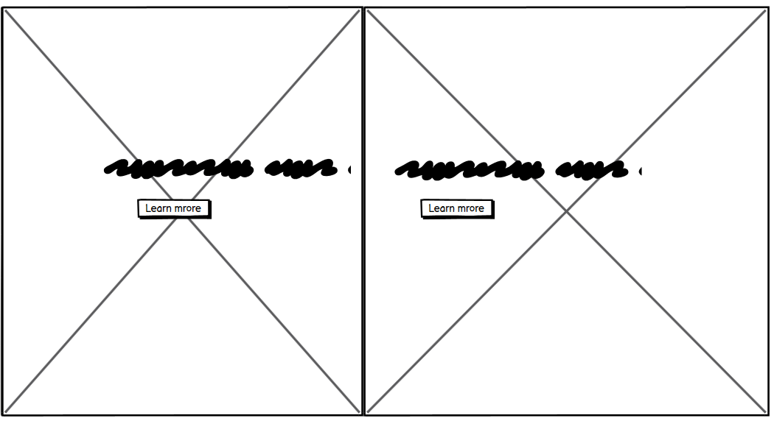

## Bentota turtle hatchery

## Kosgoda turtle hatchery

## Purchase and donate page.

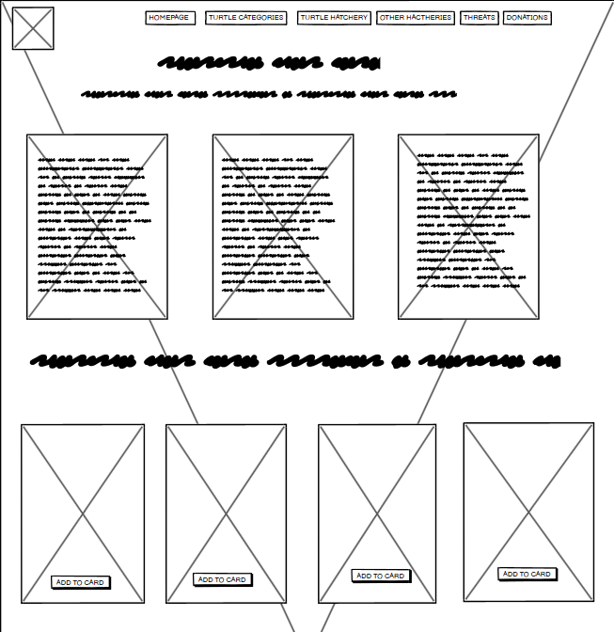

# **Mobile version**

## Homepage -Mobile

## Turtle category page-Mobile

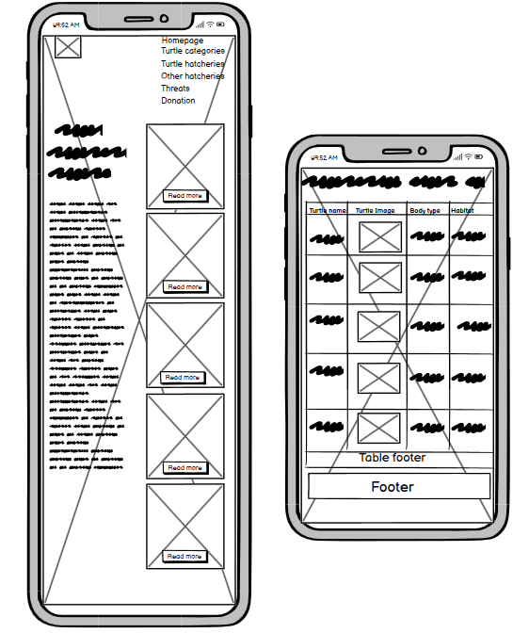

## Category section page-Mobile

## Hikkaduwa turtle hatchery-Mobile

## Other hatchery pages-Mobile

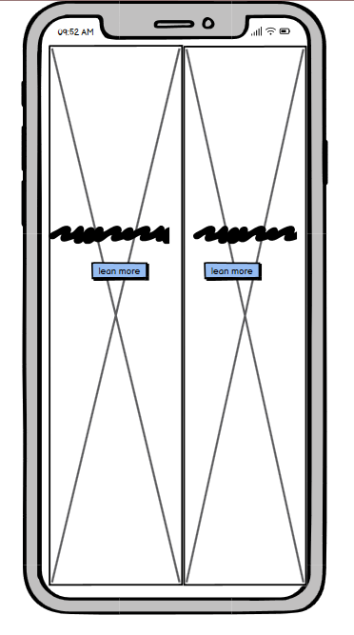

## Kosgoda hatchery page-Mobile

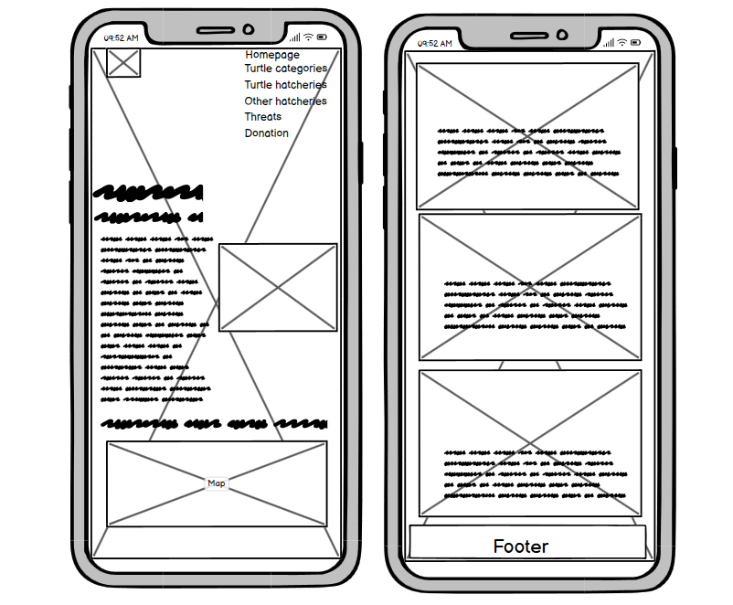

## Bentota hatchery page-Mobile

## Threat page-Mobile

## Donation page-Mobile

## GitHub link

## Conclusion